Empathize & Discover
Ideation Phase — Empathy Map Canvas
Date | 31 January 2025
Team ID | SWTID-2026-1074
Project Name | SB Stocks
Team Size | 5
Team Leader | Venkatesh Illa
Team Members | Durga Meghana Kondempudi, Chandrika Narla, Mogali Shyam, Sravani Jagu
Maximum Marks | 4 Marks

Empathy Map: The Retail Learner Trader
An empathy map captures the target user’s behaviours and attitudes, helping the team design SB Stocks around what the user actually says, thinks, does and feels.
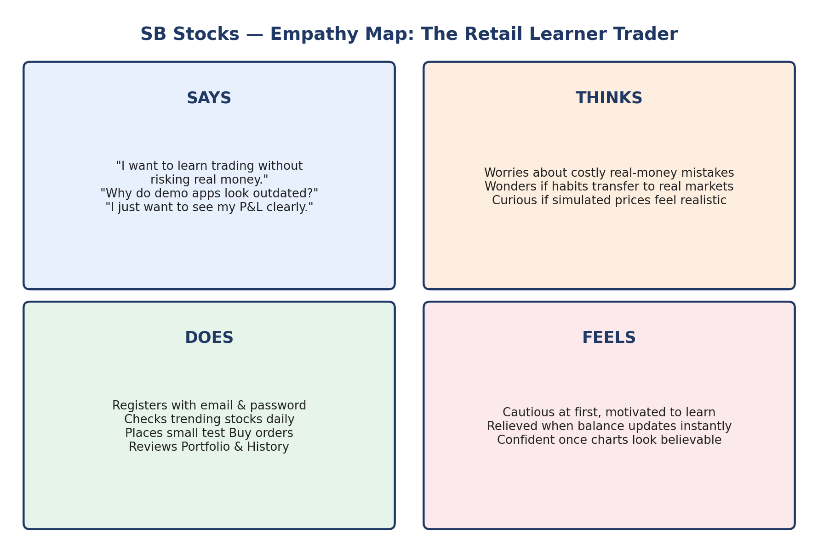
Figure: Empathy map for the SB Stocks retail-learner persona

Says
- "I want to learn trading but I don’t want to lose real money while figuring it out."
- "Why do all the demo apps look so outdated?"
- "I just want to see my profit/loss clearly."

Thinks
- Worries about making a costly mistake with real capital.
- Wonders if paper-trading habits will actually transfer to real markets.
- Is curious whether simulated prices move realistically.

Does
- Registers with an email and password.
- Checks the trending stocks list daily.
- Places small Buy orders to test the platform.
- Frequently checks Portfolio and Transaction History.
- Deposits virtual funds before trying new strategies.

Feels
- Motivated but cautious at first.
- Relieved once the wallet balance and holdings update instantly and correctly.
- Confident once the stock chart confirms price movement looks believable.

Pains
- Confusing UIs on existing simulators.
- No clear separation between Intraday and Delivery orders.
- Unclear transaction trail.
- No simple admin oversight for classroom/team use.

Gains
- A clean dashboard combining trending stocks, wallet balance, holdings and history.
- Instant feedback after every Buy/Sell order.
- A safe environment to repeat trades until confident.

